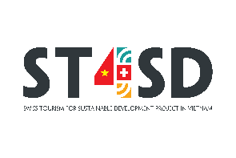
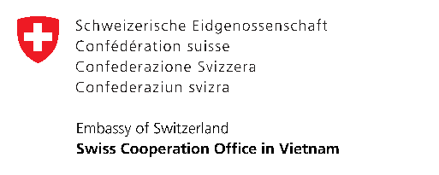
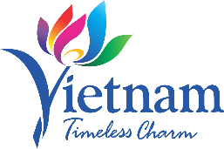

CONCEPT NOTE TEMPLATE
INNOVATIVE IDEAS FOR SUSTAINABLE TOURISM PRODUCT DEVELOPMENT

Date of application:
Project name:

Name of applicant/ company:
Acronym (optional):
Organization/ business status:
Address:
Phone:
E-mail:
Webpage:
Name of company representative:

Contact person:
Position:
Phone:
E-mail:

1) Briefly introduce yourself and your organization/company (max. 300 words):
Please include the following information:
- Year of establishment
- Business area
- Core products or services
- Main business activities
- Number of employees (disaggregated by gender)
- Annual turnover
- Ownership structure

2) What specific problem are you aiming to address through innovation in tourism activities? (max. 300 words):
Describe the challenge your idea seeks to solve. You may refer to:
- The relevance of the issue within the context of sustainable tourism in Vietnam
- Current challenges in existing sustainable tourism activities
- An opportunity to improve or transform through innovation to address sustainability challenges in local tourism activities — for example: reducing waste, preserving culture, and supporting local communities.

3) Please give a summary of the innovative idea: (1,000 words)
Please provide a concise summary of your proposed idea, highlighting its innovative aspects, objectives, and relevance to sustainable tourism. You may include:
• A description of how you plan to integrate this idea into your current business operations or future activities.
• Specific examples of new products/services or improved operational processes based on the idea.
• An explanation of how your idea connects to tourism — for example, by creating unique visitor experiences, linking with agriculture, traditional crafts, or local cultural elements.
• A plan for scaling up the idea: expanding its scope, developing new products/services, or reaching new markets.
• Clear, measurable goals such as increasing revenue, attracting more visitors, or generating employment for the local community.
• A description of how the idea contributes to making the locality a sustainable destination and aligns with its tourism development strategy.
• An emphasis on the uniqueness and distinctiveness of the idea compared to existing tourism activities.

4) Target beneficiaries and expected impact (Max. 200 words)
Who are the direct beneficiaries of your idea? Please specify their profile (e.g., local communities, businesses, tourists), their location, and explain how they will benefit.

5) Implementation Timeline (Max. 200 words)
Please outline the key phases or milestones, and the total time required for completion.

6) Please describe the alignment of the idea results with the contest objectives:
Results table:
Areas of intervention | Expected results / value

7) Previous grants: Information on support from other donors over the past 3 years
Name of Donor/Project | Amount | Year | Purpose of the grant

8) Cost of project and details of other funding
Please provide a breakdown of the total estimated cost of the idea and specify sources of funding. Indicate how much you are contributing, any third-party support, and the amount requested from the ST4SD project.

Funding Summary
Source of Funding | Amount (USD or VND) | Notes
Own investment
Third-party contributions
Amount requested from ST4SD
Total estimated project cost

Cost Breakdown by Category
Category | Description | Amount  (USD or VND) | Notes
Purchase of services
Purchase of equipment
Purchase of materials
Other (please specify)
TOTAL

Submitted by: _______________________

Date and place: _______________________

